Eastcoast Housing

Newsletter

UPDATES from the Managing Director.

Rent Reviews: Recent discussions have resulted in a decision to limit rent reviews to once a year. This will occur in November/December each year from now on. This way we can incorporate both the Market Rent advice from DHHS and the increases in Centrelink benefits that occur in March and September each year.

Eastcoast will continue to reassess rent at other times when a household’s income changes from the date the change is notified to us.

Victorian Housing Register: Eastcoast will be merging our waitlist with that of the Victorian Housing Register soon. We will be sending out advice to all those currently on our waitlist asking if they want us to transfer them across to this statewide list.

Pet Care: I was recently appalled at the condition of a pet in one of our properties. I have instructed my staff to report all cases of neglect and abuse of pets to the RSPCA.

New Policies: We have updated/implemented policies covering “Child Protection Reporting” and “Reportable Conduct Scheme”. Along with these we have also developed a raft of policies in anticipation of the opting in to the Victorian Housing Register. These new policies will cover eligibility, Allocations and Rent. If anyone is interested in viewing these documents and making comment please email me for copies at housing@eha.org.au

Upcoming events  19th of October 2018. We will be holding a free information session centered on finances, managing and avoiding debt, budgeting, and where to seek help.  This is a free session and we invite all tenants to attend.  Come and meet the team and have afternoon tea with us | Future events  16th of November 2018 day trip to Australian Gardens, Cranbourne  14th of December 2018 Christmas gathering at Eastcoast Housing.  If you have any ideas about what events / outings Eastcoast housing should have please let us know. |  | Tip Vouchers  If you are in need of a tip voucher please contact the office. You will be provided with one if it has been issued with our rates notices.
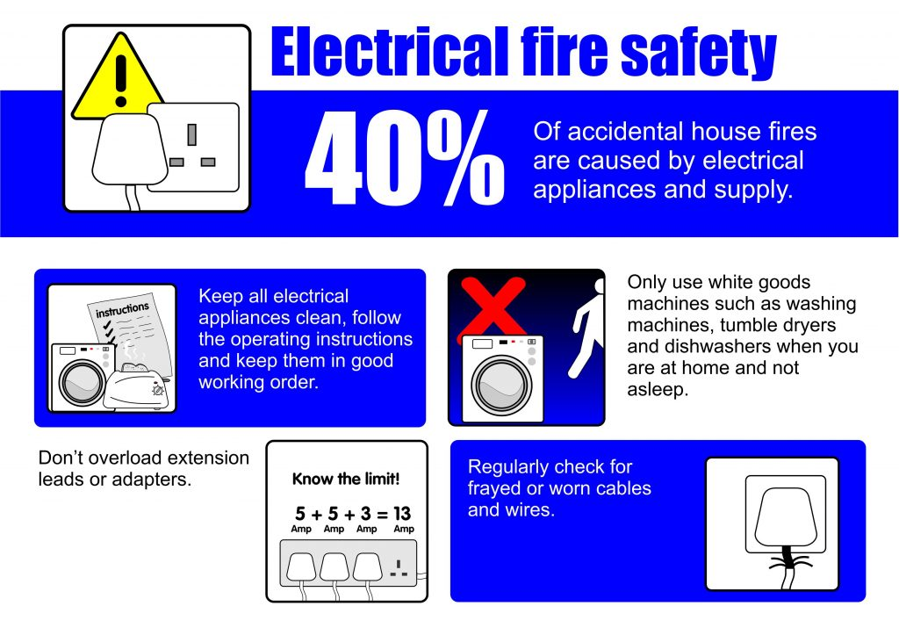  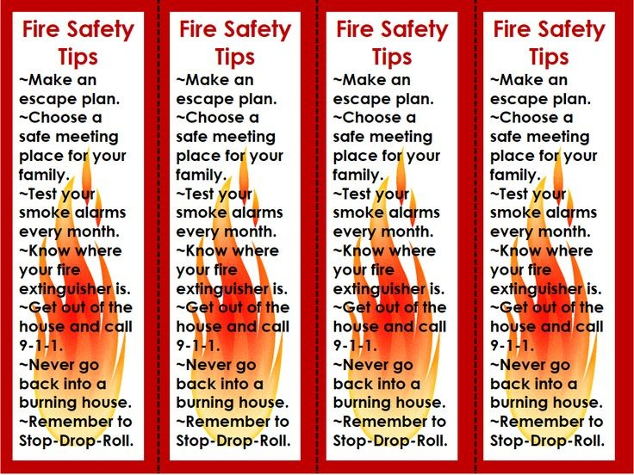 |  | fire and electrical saftey  Recently one our homes was affected by a fire that started in a caravan. Thankfully all residents of this property are safe and no major damage has been caused to the home.  It is believed that the source / cause of the blaze was a faulty generic laptop charge similar to the ones you can buy on eBay or at discount shops. When purchasing items such as charges, power boards, extension leads, adapters and other electrical items it is always worth checking the following:  Does this item comply with Australian standards?  Does it have a recognised approval number?  Does it have a Regulatory Compliance Mark?  If it doesn’t or you are unsure you can check this by visiting https://equipment.erac.gov.au/Public/ here you can search the model number to ensure that it complies with Australian standards.  Eastcoast Housing recommend that electronic devices be purchased from reputable store such as Harvey Norman, Kmart, Good Guys, Betta Electrical, and Dick Smiths.  Eastcoast Housing strongly recommend that all our tenants implement fire safety and fire prevention plan for their home.
Air conditioners
With the warmer weather approaching Eastcoast Housing want to remind all our tenants that we do not install or provide air conditioners or ceiling fans. Eastcoast Housing will not approve the installation of Ceiling fans.
Eastcoast Housing recommend using portable air conditioners and pedestal fans.
Not only are they more cost effective to run but you can move them around the house as needed.
You can purchase portal air conditioners and pedestal fans from Kmart. Aldi, Big W, Target, The Good Guys, Harvey Norman and other leading electrical stores.

For many pets are important members of the family. A pet can be a joy but they are a big responsibility. Choosing the right pet for you is fun, but takes time, planning and lots of research. You need to consider very carefully both your needs and the needs of the animal that comes into your life.
As a pet owner you need to ensure that you are able to meet your pet’s needs, this includes providing a safe and caring environment, regular health checks, exercise, access to food and fresh water daily, cleaning up any animal waste and preventing your pet from causing damage to your home.
Our housing workers Krystal and Warren have provided a breakdown of what is required of them to ensure their pets are adequately cared for.
Krystal 1 x Dog (Max) and 1 x Senior Cat (Tiddles). Warren Williams’s 1 x cat
Max: 1-2 hrs. Of walking and play per day Tiddles: very sedative life style (old man) Allan: likes to sleep and plays 30mins-1hr per day.
Food: $776.00 per year Food: $483.25 per year Food: $1200.00 per year
Dental: $320.00 per year Toys bedding and other items: $60.00-$100 Toys bedding and other items: $50.00-$100.00
Toys bedding and other items: $50.00-$100 Kitty Litter: $168.00 per year. Kitty Litter: $252.00
Boarding / Kennels: $300.00 per year. Boarding / Kennels: $300.00 per year Medical Cost: $250.00 this year
Medical Cost: $2500.00 this year. Medical cost: $200.00 per year. Registration fees: $43 per year
Registration fees: $43 per year Registration fees: $43.00
Total: $3701.00 Total: $1254.25 Total: $1845.00
Recently our Managing Director Meigan joined workers for their routine inspections. During one of these inspection Meigan came across a kitten that required urgent medical attention. The owners of the kitten held off on treatment as they were unable to afford the cost associated with a vet visit. Unable to leave the animal in the condition it was in. Meigan instructed the owners to take the kitten to the vets and that Eastcoast Housing would assist in seeking treatment for the kitten. However when the kitten was taken to the vet it was too late the infection caused by the wound had spread to the spinal cord and the kitten was euthanized.
Please understand Eastcoast Housing staff will not hesitate to report incidents of neglect and abuse of animals to the RSPCA.

Op-Shop day  Recently staff and tenants enjoyed a day out op-shopping. It was a great day out with tenants and staff visiting op-shops around Pakenham and Gippsland. | 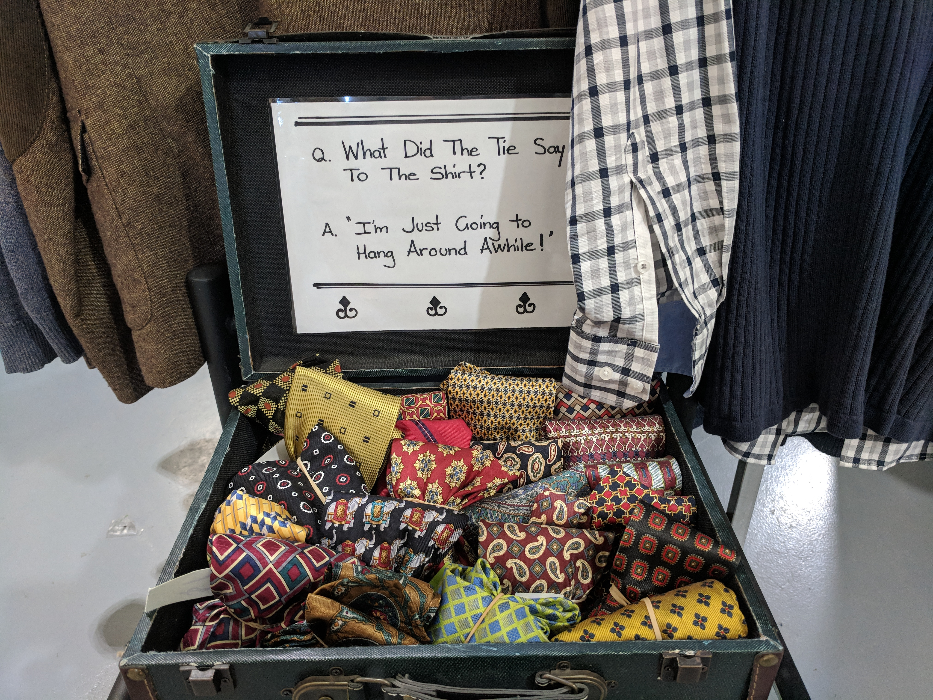
Weird Facts.  Most toilets flush in E flat.  Approximately 40,000 Americans are injured by toilets each year.  If a female ferret does not have sex for over a year, she will die.  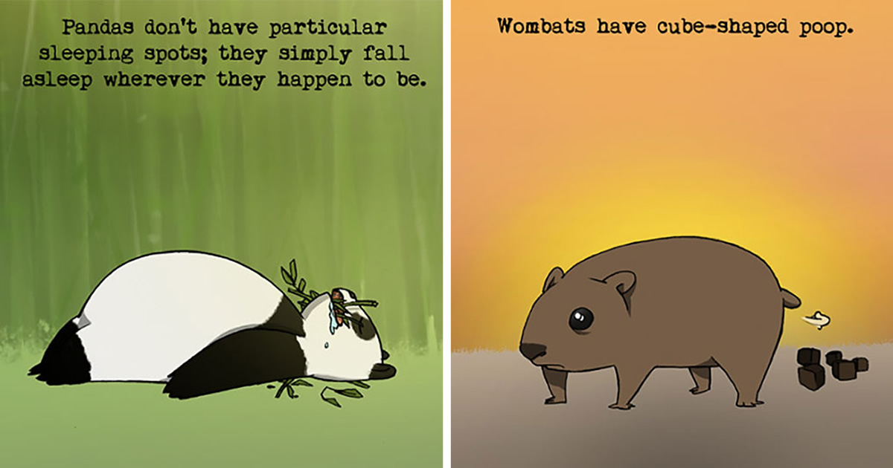  Ketchup was sold in the 1830s as medicine.  “Almost” is the longest word in English with all the letters in alphabetical order.  Steve Jobs relieved stress by soaking his feet in Apple’s company toilets. | It is impossible to sneeze with your eyes open.  There is a town in Canada called “Dildo.”  No piece of square paper can be folded more than 7 times in half.  A duck’s quack doesn’t echo, and nobody can figure out why.  The Romans used to clean and whiten their teeth with urine. Apparently it works?  Crocodile poop used to be used as contraception.  